Web Programming
Assignment-2
Cricket Game

Presentation Report

Submitted by
Muhammad Moiz Ansari 23i-0523

Semester-6

Submitted to
Ma’am Tajwar


Department of Computer Science National University of Computer and Emerging Sciences Islamabad, Pakistan

Contents
Gameplay Screenshots 3
1. Aggressive Batting 3
2. Defensive Batting 3
3. Power Bar 3
4. Scoreboard 4
5. Game Over Screen 4
Brief Explanation 4
1. Game Logic and working mechanism 4
2. Mapping of probabilities to the power bar 4
3. Implementation of animations 4
GitHub Repository Link 4

Gameplay Screenshots

Aggressive Batting
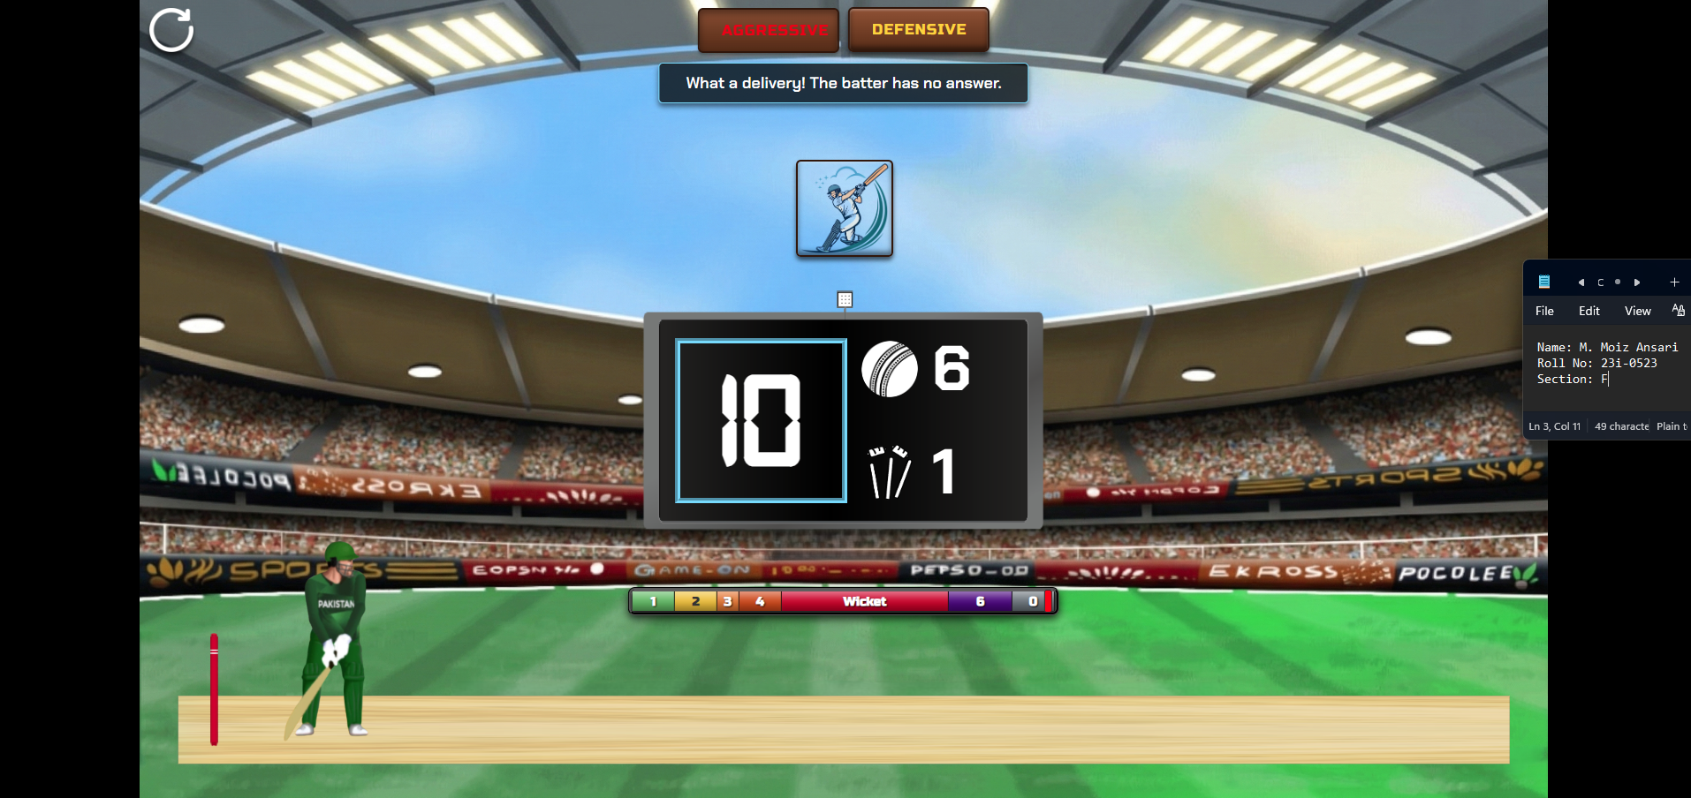

Defensive Batting
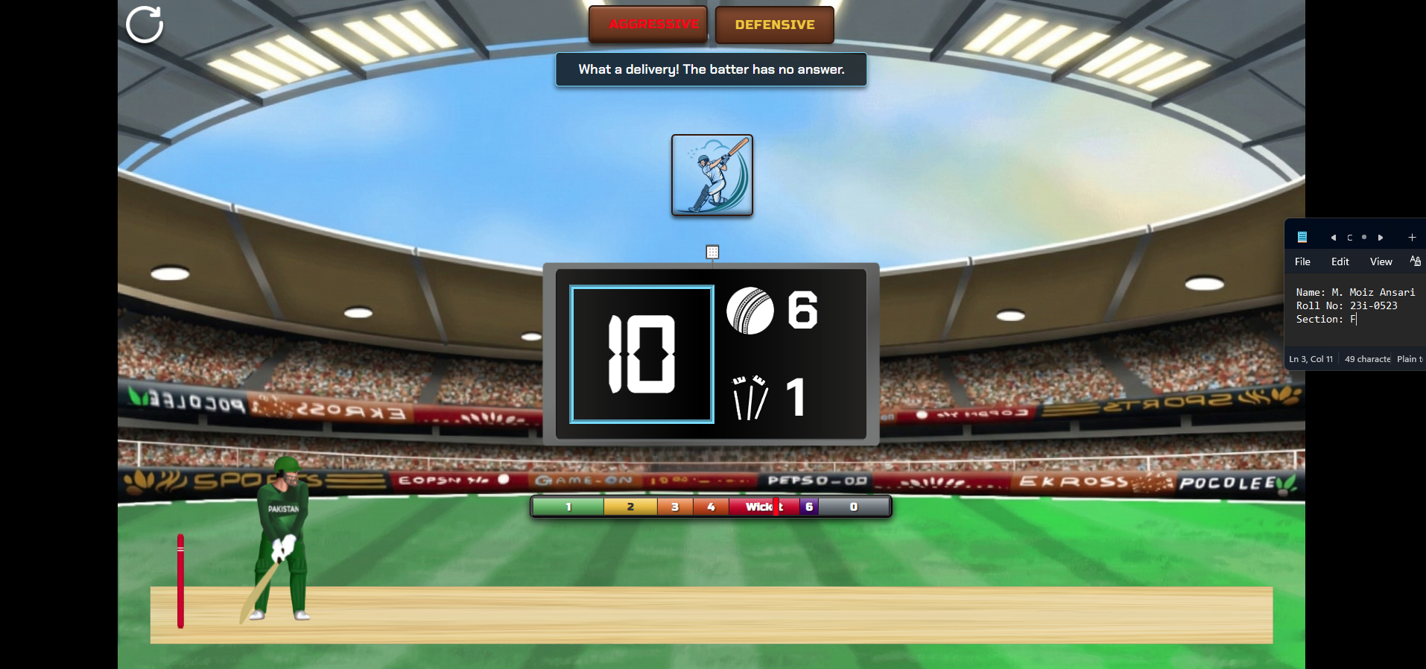

Power Bar
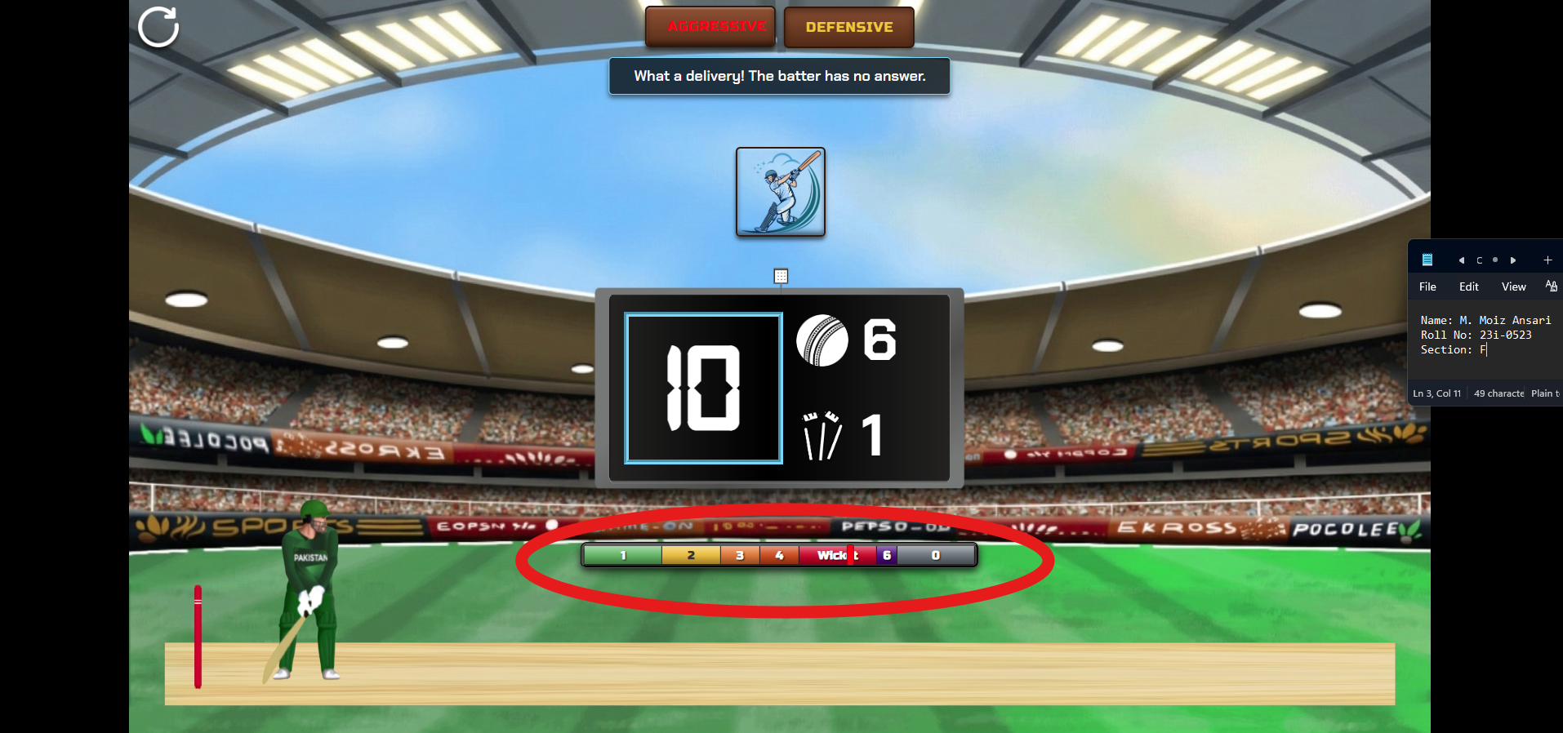

Scoreboard
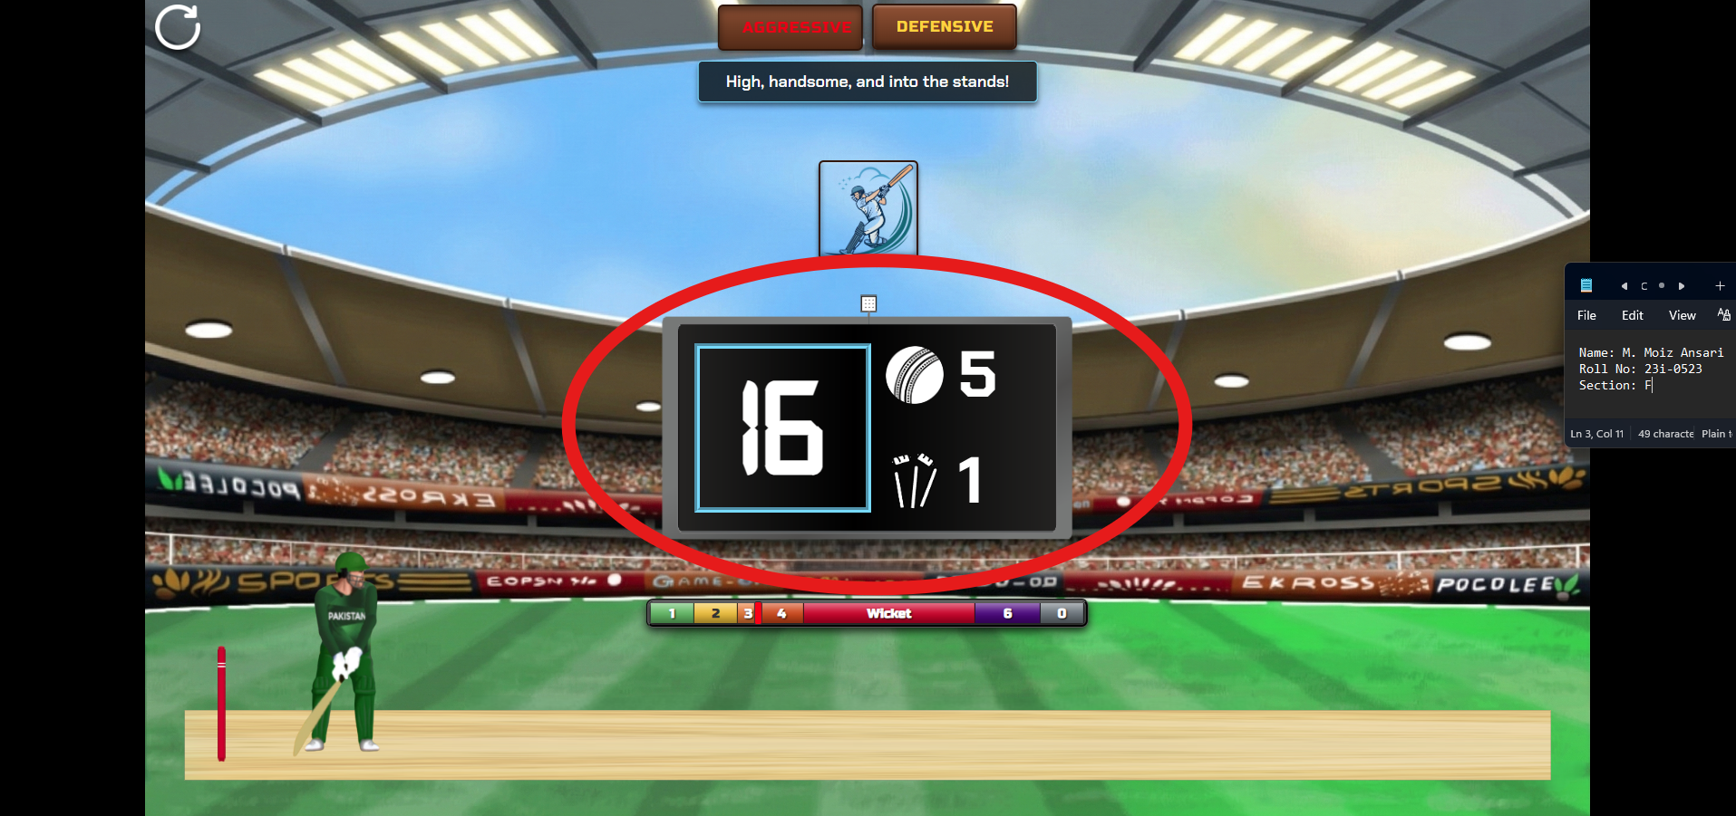

Game Over Screen
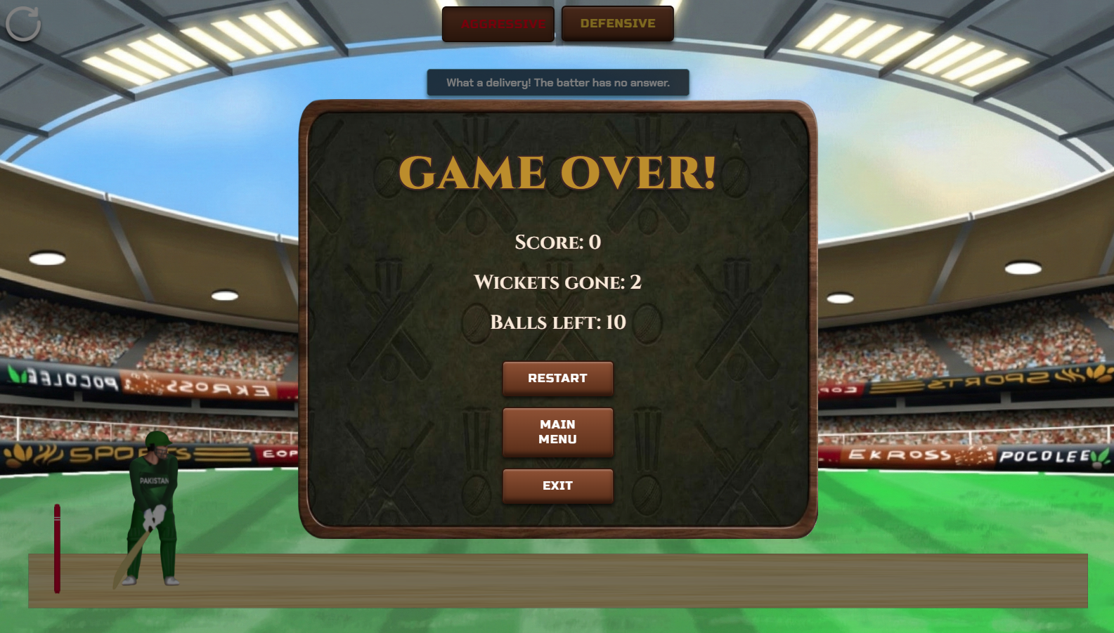

Brief Explanation

Game Logic and working mechanism
When the game starts the slider bar is continuously moving. When we press the Play Shot button, the slider will stop changing its value hence stop there. Then the ball animation will start which will when reach near the batter, trigger the batter animation to start. It will then start the ball shot animation which will go back with certain horizontal and vertical velocities according to the outcome where slider have landed. For ball animations, I have used vertical-based trajectory because it is easier to use that for bouncing ball logic. In case of wicket outcome, the batter will miss shot and ball will hit wickets which will then play its own animation using transform function.

Mapping of probabilities to the power bar
The probabilities are stored in arrays of objects for both batting styles separately. These arrays are then mapped into HTML <div> segments. The width of each colored segment is directly died to its percentage using inline styling (width: ${stat.prob}%). When we press the Play Shot button, the slider stops and the sliderPos integer is captured an then it is compared to the cumulative sum of probabilities to check where the slider landed.

Implementation of animations
For the slider bar animation I have used setInterval useEffect which runs forever in the background until the game is closed. For the rest of animations, I have used setInterval inside the function playShot. These animations run in a sequence triggering other animations and stopping on specific conditions.

GitHub Repository Link
https://github.com/muhammad-moiz-ansari/Web-Programming-Tasks

